Assignment 2 (SSIS Airports Master Data Flow)

Create Relationship Between Airports and States
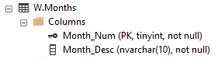
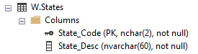
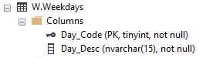
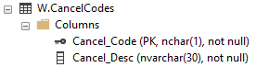
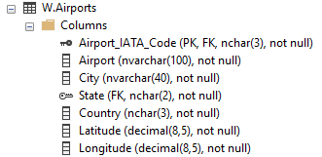
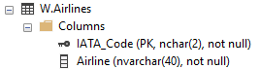
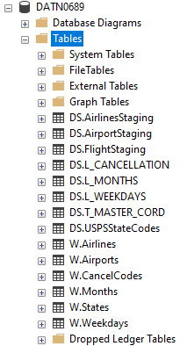

Create DS.CurrentAirports2015 Table from DS.T_MASTER_CORD
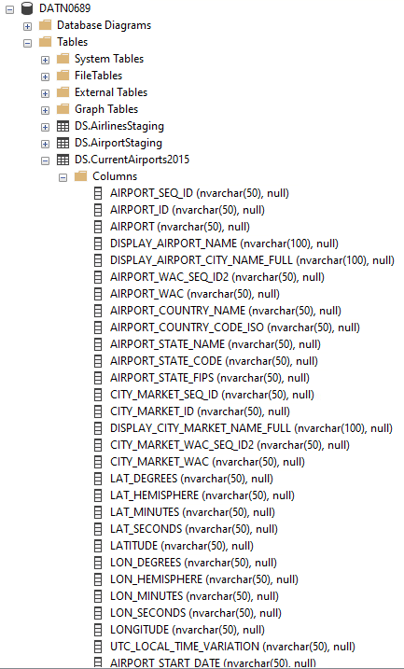

Load Current Airport Data into DS.CurrentAirports2015
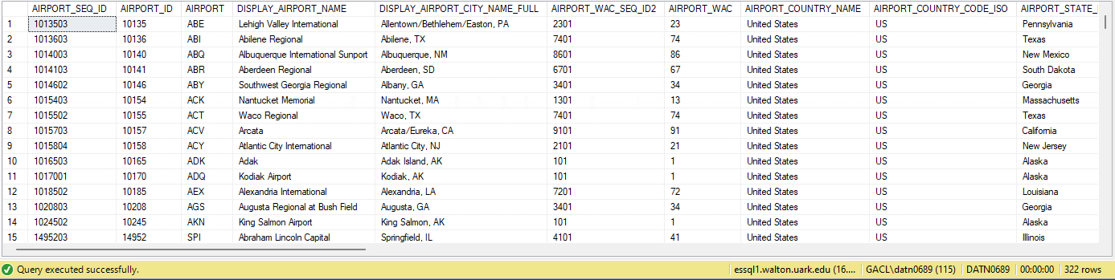
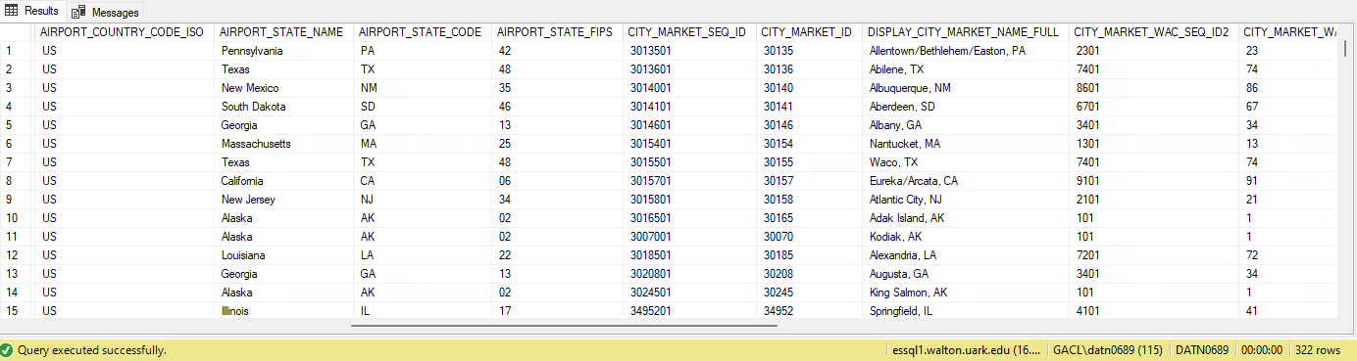
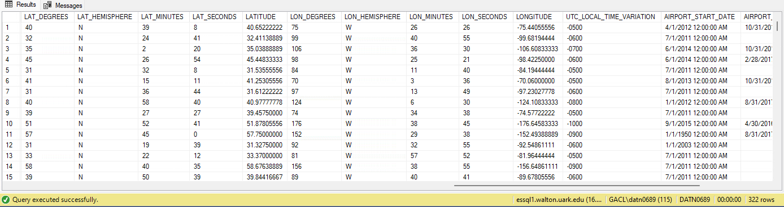
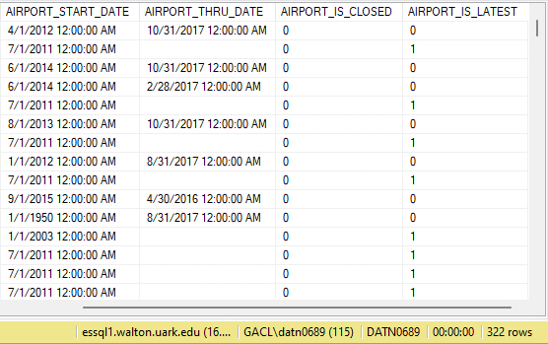
Airports Data Flow
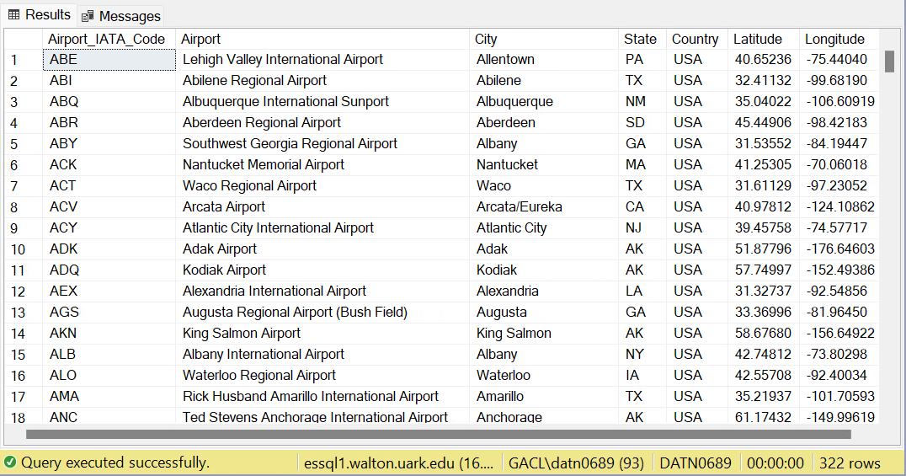
Second Check
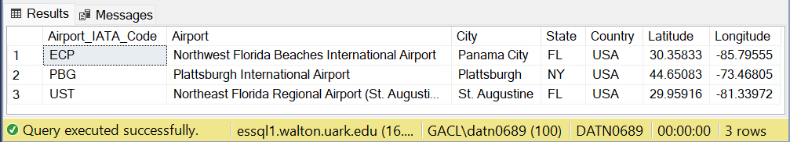
SELECT *
FROM W.Airports
WHERE Airport_IATA_Code IN ('ECP', 'PBG', 'UST');

W Schema Database Diagram
